**Retrieve the entire contents of customer table.**

SELECT *

FROM

Customer;

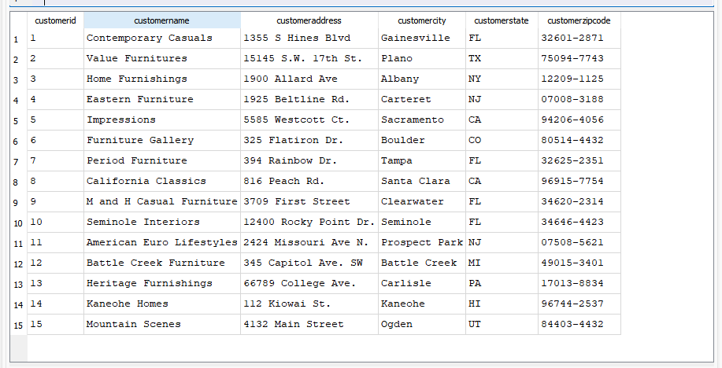

**Display all the columns for customers who are from FL (Florida), sorted by customer name in descending order.**

SELECT *

FROM

customer

WHERE

customerstate = 'FL'

ORDER BY

customername DESC;

**For each product that has a price of 200, 250, or 325, retrieve the productid, product description, product price.**

SELECT

productid,

productdescription,

productprice

FROM

product

WHERE

productprice IN (200,250,325);

**Retrieve the product id, product description, product price, and product line id from the product table for each product whose product price is greater than 300 AND whose product id is smaller than 5.**

SELECT

productid,

productdescription,

productprice,

productlineid

FROM

product

WHERE

productprice > 300

AND productid < 5;

**Retrieve the product description and product price for each product whose product description contains the phrase 'Desk' OR whose product price is less than 600.**

SELECT

productdescription,

productprice

FROM

product

WHERE

productdescription LIKE '%DESK%'

OR productprice < 600;

**Retrieve the number of products, average product price, lowest product price, and highest product price for products assigned to product line 2.**

SELECT

COUNT (*),

avg (productprice),

MIN (productprice),

MAX (productprice)

FROM

product

WHERE

productlineid = 2;

**For each type of product finish, retrieve the product finish, the number of products using that product finish, and the average price of the products using that product finish.**

SELECT

productfinish,

COUNT (*),

AVG (productprice)

FROM

product

GROUP BY

productfinish;

**Consider each group contains the products with the same product finish assigned to the same product line. For each group that has *more than one* product, retrieve the product finish, product line id, and the number of products in the group.**

SELECT

productfinish,

productlineid,

COUNT (*)

FROM

product

GROUP BY

productfinish,

productlineid

HAVING

COUNT (*) > 1;

